EXPT NO:3 | Designing Multivariate Patterns
Roll No: 23BAD078 | Designing Multivariate Patterns
DATE: 12.01.2026 | Designing Multivariate Patterns

PRE-LAB QUESTIONS (PROVIDE BRIEF ANSWERS TO THE FOLLOWING QUESTIONS)
- Why is multivariate analysis essential in real-world AI problems?
Answer: Multivariate analysis is essential because real-world AI problems involve multiple interacting variables that must be analysed together to make accurate predictions or decisions.
- What challenges arise when visualizing high-dimensional data?
Answer: High-dimensional data is difficult to visualize because of visual clutter, overlapping information, and limitations of two- or three-dimensional displays.
- How does correlation analysis support feature selection?
Answer: Correlation analysis helps identify redundant or irrelevant features by measuring relationships between variables, allowing selection of the most informative features.
- What are ethical concerns in healthcare data visualization?
Answer: Ethical concerns include patient privacy, data misinterpretation, bias, and misuse of sensitive health information.
- Give examples of multivariate data in AI systems.
Answer: Examples include patient records with multiple health metrics, sensor data from autonomous vehicles, and user behavior data in recommendation systems.
IN-LAB EXERCISE:
OBJECTIVE:
To discover relationships among multiple variables using multivariate visualization.
SCENARIO:
A hospital analytics team studies patient health records to identify relationships between age, BMI, glucose levels, and blood pressure for early disease prediction.
IN-LAB TASKS (Using R Language)
- Generate scatter plot matrix
- Apply color encoding for age groups
- Identify correlated health indicators

(CODE: CONATAINS STUDENT ROLL NOS
SCREENSHOT OF CODE
SCREENSHOT OF OUTPUT)

Code:

print("Roll No. 23BAD078")
library(ggplot2)
library(GGally)
head(health_data)
ggpairs(
health_data,
columns = c("Age", "BMI", "Glucose_Level", "Blood_Pressure"),
aes(color = AgeGroup)
)
cor(
health_data[, c("Age", "BMI", "Glucose_Level", "Blood_Pressure")]
)
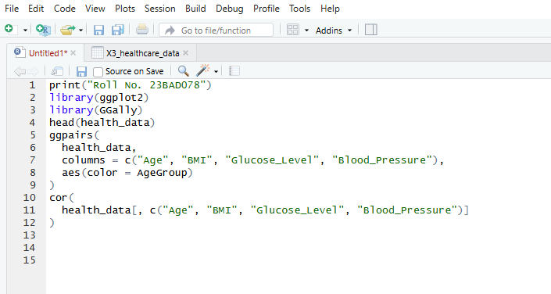

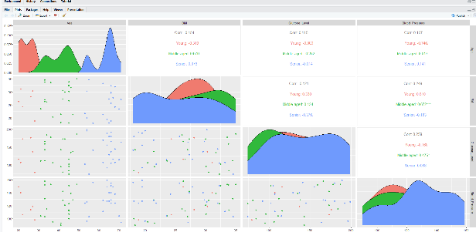

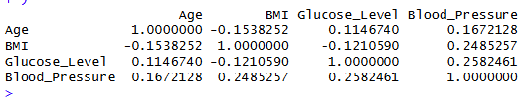

POST-LAB QUESTIONS (PROVIDE BRIEF ANSWERS TO THE FOLLOWING QUESTIONS)
- Which health parameters show strong correlation?

Answer: BMI shows a moderate positive correlation with Blood Pressure, and Glucose Level also shows a positive correlation with Blood Pressure.

- Why correlation does not imply causation in medical data?

Answer: Because correlated health variables may be influenced by other hidden factors, and one variable increasing does not prove it directly causes the change in another.

- How can these patterns assist predictive healthcare AI?

Answer: These patterns help AI models identify important risk-related features and improve early disease prediction accuracy.

- What visualization limitations exist for high-dimensional data?

Answer: High-dimensional data causes overlapping points, visual clutter, and makes relationships difficult to interpret using simple plots.

- How can dimensionality reduction improve visualization?

Answer: Dimensionality reduction reduces the number of variables while preserving key patterns, making complex data easier to visualize and understand.

ASSESSMENT
Description | Max Marks | Marks Awarded
Pre Lab Exercise | 5
In Lab Exercise | 10
Post Lab Exercise | 5
Viva | 10
Total | 30
Faculty Signature

